NEWSLETTER

June 2017

1 | NAME OF THE SSC | Security Sector Skill Development Council
2 | TYPE OF ACTIVITY | Meeting with Aviation & Aerospace SSC
3 | DATE | 01 June 2017
4 | LOCATION | NSDA
5 | KEY ACTORS OF THE ACTIVITY | Manager SQA
6 | ABOUT THE EVENT/ ACTVITY (in max 200 words) | Discussions were held at NSDA with Aviation and Aerospace SSC regarding development of QP-NOS for Airline Security Executive. The meeting was chaired by DG, NSDA and attended by CEOs of concerned SSCs. Manager SQA was also present. The meeting discussed the QP NOSs to be prepared for SSC.
7 | RELEVANT PICTURES  (ATTACH GOOD QUALITY PICTURES SEPARATELY) | 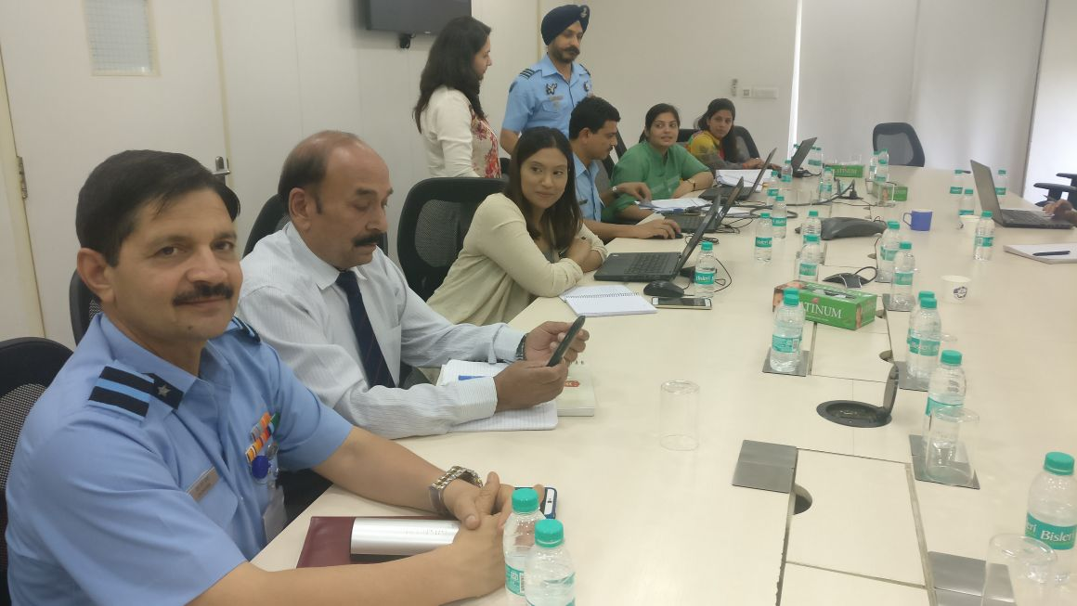
8 | DRAFTED BY | EA to Chairman
9 | VETTED BY | HR & Admin

1 | NAME OF THE SSC | Security Sector Skill Development Council
2 | TYPE OF ACTIVITY | Global Skill & Employment Partnership Summit (GSEP)
3 | DATE | 01 June 2017
4 | LOCATION | Bhopal
5 | KEY ACTORS OF THE ACTIVITY | Manager Projects
6 | ABOUT THE EVENT/ ACTVITY (in max 200 words) | Manager Projects attended Global Skill & Employment Partnership Summit at Bhopal on 1st June 2017. More than 3000 participants turned up, more from the public side, schools, colleges and NGOs.  Some of the important Dignitaries present during the inauguration session are:  - Hon’ble Chief Minister of MP – Mr. Shivraj Singh Chouhan  - Hon’ble Union Minister of State for Skill Development and Entrepreneurship (Independent Charge) – Mr. Rajiv Pratap Rudy.  - Hon’ble Minister for Commerce Industry & Employment, Govt of MP - Mr Rajendra Shukla  - Chairman, MP Rozgar Nirman Board – Mr. Hemant Vijayrao Deshmukh  - Chief Secretary, Govt of MP – Mr. Basant Pratap Singh  - Principal Secretary, Technical & Skill Development Dept, Govt of MP – Mrs. Kalpana Srivastava  - Chairman, CII National Committee on Skill Development – Mr. Arun Nanda  Hon’ble Chief Minister elaborated on the great strides being taken by the government in the direction of creating employment opportunities in the industry and transforming the state of Madhya Pradesh into an unemployment-free state with an immediate need to create a link between workforce and industry for generating gainful employment and creating entrepreneurship opportunities through MP Rojgar Nirman Board.  The inauguration had many dignitaries speak on the role of the government, the industry as well as the public who should play an important part in the skilling of the youth. The session ended with lunch.  MOU SIGNING CEREMONY :  The exchange of MoU between all the SSCs and MPSSDM was held in the afternoon session and on behalf of Security Sector Skill Development Council, Manager – Projects took the stage for the exchange with the Officer from MPSSDM.
7 | RELEVANT PICTURES  (ATTACH GOOD QUALITY PICTURES SEPARATELY) | 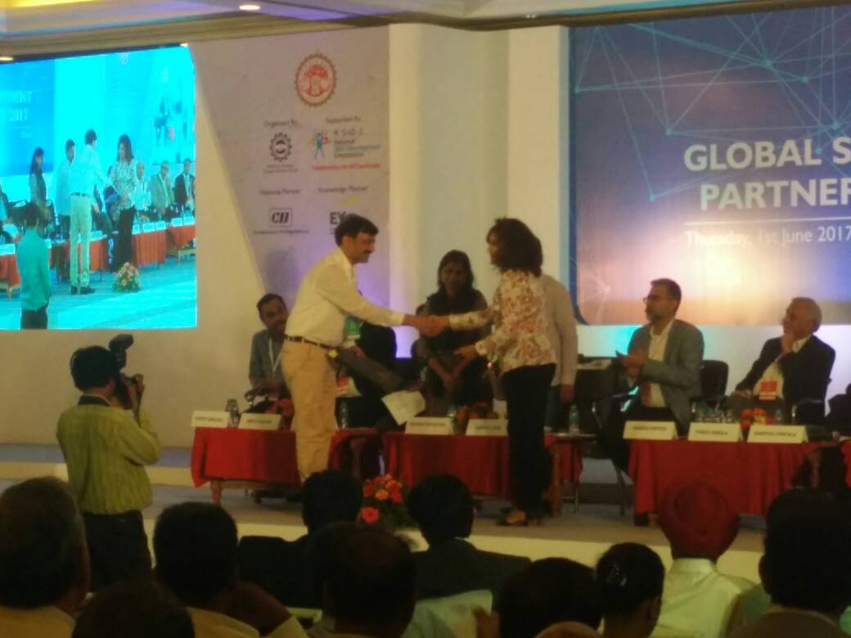
8 | DRAFTED BY | EA to Chairman
9 | VETTED BY | HR & Admin

1 | NAME OF THE SSC | Security Sector Skill Development Council
2 | TYPE OF ACTIVITY | Meetings at NSDC
3 | DATE | 08 June and 21 June
4 | LOCATION | NSDC Office
5 | KEY ACTORS OF THE ACTIVITY | COO & Manager SQA
6 | ABOUT THE EVENT/ ACTVITY (in max 200 words) | 8 June – Meeting was held at NSDC regarding handing over of content to Rachna Sagar Pvt. Ltd., the Publisher, for Unarmed Security Guard. The meeting was attended by COO and Manager SQA.  21 June- A follow up meeting was held at NSDC regarding handing over of content to the Publisher Rachna Sagar Pvt. Ltd. for printing of student handbooks. The meeting was chaired by Mr. Jayant Krishna, ED and COO, NSDC. It was attended by Manager SQA. Mr. Manish Kumar, MD, NSDC also addressed all present and said that the timelines for submitting the contents to the publisher should be strictly adhered to.
7 | RELEVANT PICTURES  (ATTACH GOOD QUALITY PICTURES SEPARATELY) | NA
8 | DRAFTED BY | EA to Chairman
9 | VETTED BY | HR & Admin

1 | NAME OF THE SSC | Security Sector Skill Development Council
2 | TYPE OF ACTIVITY | Visit to VSDU
3 | DATE | 05 June 2017
4 | LOCATION | Vishwakarma Skill Development University
5 | KEY ACTORS OF THE ACTIVITY | Chairman, COO & Manager Entp.
6 | ABOUT THE EVENT/ ACTVITY (in max 200 words) | A meeting was held at VSDU on 5 June at 1030 hrs to discuss collaboration between the two organizations in respect of conducting B Voc courses in Security Domain. Chairman, COO & Manager Entp. represented SSSDC whereas Raj Nehru and Ms. Chanchal participated in the deliberation from VSDU. It was decided to meet again to crystalize the job roles that can be undertaken.
7 | RELEVANT PICTURES  (ATTACH GOOD QUALITY PICTURES SEPARATELY) | NA
8 | DRAFTED BY | EA to Chairman
9 | VETTED BY | HR & Admin

1 | NAME OF THE SSC | Security Sector Skill Development Council
2 | TYPE OF ACTIVITY | NSKFDC Meet
3 | DATE | 06 June 2017
4 | LOCATION | New Delhi
5 | KEY ACTORS OF THE ACTIVITY | COO
6 | ABOUT THE EVENT/ ACTVITY (in max 200 words) | A meeting was held at NCUI Building, August Kranti Marg on 6 June 2017. The meeting was organized by NSKFDC. COO, SSSDC attended the meet. Mr. K Narayan, MD NSKFDC chaired the meet. MR KK Bhagat NSKFDC gave a presentation om the functioning of NSKFDC and the various schemes undertaken by them. The specific issues related to Safai Karamcharis and Manual Scavengers were highlighted. The NSKFDC authorities requested participating sector skill councils to identify vacancies in various states across the Country where skilling of these category of youth can be undertaken.
7 | RELEVANT PICTURES  (ATTACH GOOD QUALITY PICTURES SEPARATELY) | N A
8 | DRAFTED BY | EA to Chairman
9 | VETTED BY | HR & Admin

1 | NAME OF THE SSC | Security Sector Skill Development Council
2 | TYPE OF ACTIVITY | NSKFDC Meet
3 | DATE | 06 June 2017
4 | LOCATION | SSSDC Office
5 | KEY ACTORS OF THE ACTIVITY | COO, TPs and NSKFDC Reps
6 | ABOUT THE EVENT/ ACTVITY (in max 200 words) | Following up on the meeting held on 06 June by NSKFDC, SSSDC organized a similar meet at their office for the training providers willing to participate in the NSKFDC projects on 14 June. The meeting was attended by 8 training providers and representatives of NSKFDC and chaired by COO, SSSDC. The meeting focused on how the training providers could mobilize the affected youth of the category and organize training for them. NSKFDC representatives highlighted the peculiarities associated with these categories person. The COO requested the participating TPs to forward the numbers that they can be compiled for onward submission to NSKFDC.
7 | RELEVANT PICTURES  (ATTACH GOOD QUALITY PICTURES SEPARATELY) | NA
8 | DRAFTED BY | EA to Chairman
9 | VETTED BY | HR & Admin

1 | NAME OF THE SSC | Security Sector Skill Development Council
2 | TYPE OF ACTIVITY | Meeting for QP-NOS
3 | DATE | 13 June 2017
4 | LOCATION | SSSDC Office
5 | KEY ACTORS OF THE ACTIVITY | COO & Manager SQA
6 | ABOUT THE EVENT/ ACTVITY (in max 200 words) | Meeting with Col Sehgal for development of QP-NOS for Industrial Security and Disaster Management, was chaired by COO and attended by Manager SQA. It was agreed that a Proposal will be submitted by Col Sehgal.
7 | RELEVANT PICTURES  (ATTACH GOOD QUALITY PICTURES SEPARATELY) | NA
8 | DRAFTED BY | EA to Chairman
9 | VETTED BY | HR & Admin

1 | NAME OF THE SSC | Security Sector Skill Development Council
2 | TYPE OF ACTIVITY | Workshop
3 | DATE | 15 June 2017
4 | LOCATION | NSDC Office
5 | KEY ACTORS OF THE ACTIVITY | Manager SQA
6 | ABOUT THE EVENT/ ACTVITY (in max 200 words) | A workshop was held at NSDC with IAF officers for benchmarking of IAF Skill Certification with NSQF.
7 | RELEVANT PICTURES  (ATTACH GOOD QUALITY PICTURES SEPARATELY) | NA
8 | DRAFTED BY | EA to Chairman
9 | VETTED BY | HR & Admin

1 | NAME OF THE SSC | Security Sector Skill Development Council
2 | TYPE OF ACTIVITY | Andhra Pradesh Mission for Elevation of Poverty in Municipal Areas
3 | DATE | 19 June 2017
4 | LOCATION | Vijaywada
5 | KEY ACTORS OF THE ACTIVITY | Manager SQA
6 | ABOUT THE EVENT/ ACTVITY (in max 200 words) | Manager SQA visited AP MEPMA (Andhra Pradesh Mission for Elevation of Poverty in Municipal Areas) at Vijayawada for a meeting for requirement of assessing bodies for the mission. Development of MOU is in progress between SSSDC and AP MEPMA.
7 | RELEVANT PICTURES  (ATTACH GOOD QUALITY PICTURES SEPARATELY) | NA
8 | DRAFTED BY | EA to Chairman
9 | VETTED BY | HR & Admin

1 | NAME OF THE SSC | Security Sector Skill Development Council
2 | TYPE OF ACTIVITY | Board of Directors Meeting
3 | DATE | 22 June 2017
4 | LOCATION | New Delhi
5 | KEY ACTORS OF THE ACTIVITY | Chairman, COO and other office staff
6 | ABOUT THE EVENT/ ACTVITY (in max 200 words) | BoD meet was held at Mohata Room, PHD Chamber, August Kranti Marg on 22 June the meeting was presided over by the Chairman and attended by Majority of the Directors of the council. Two members from NSDC also participated in the deliberations. The minutes of BoD are under preparation for circulation.
7 | RELEVANT PICTURES  (ATTACH GOOD QUALITY PICTURES SEPARATELY) | NA
8 | DRAFTED BY | EA to Chairman
9 | VETTED BY | HR & Admin

1 | NAME OF THE SSC | Security Sector Skill Development Council
2 | TYPE OF ACTIVITY | Various Training Courses
3 | DATE | June 2017
4 | LOCATION | Delhi & NCR
5 | KEY ACTORS OF THE ACTIVITY | Master Trainer
6 | ABOUT THE EVENT/ ACTVITY (in max 200 words) | - TOT 21 was conducted at Galaxy HR Services from 5-15 June 2017 in which 12 candidates participated in the course.  - TOA 12 & 14 were also conducted at Galaxy HR Services from 29 May to 03 June & Peregrine Guarding from 13-19 June. Few photographs of the course are also attached.  - TOT 25 conducted at CISS, Ahmedabad from 20-30 June. Total 10 candidates participated in the course. During the course visit of Raksha Shakti University was also arranged for the participant. Photograph attached.  - Training of Vocational Trainers of Haryana Schools was also conducted at SCERT, Gurgaon from 19-22 June 2017. Similarly, Vocational training of trainers of Delhi Schools was also conducted SBB School, Rouse Avenue, Minto Road from 22-24 June 2017.
7 | RELEVANT PICTURES  (ATTACH GOOD QUALITY PICTURES SEPARATELY) | 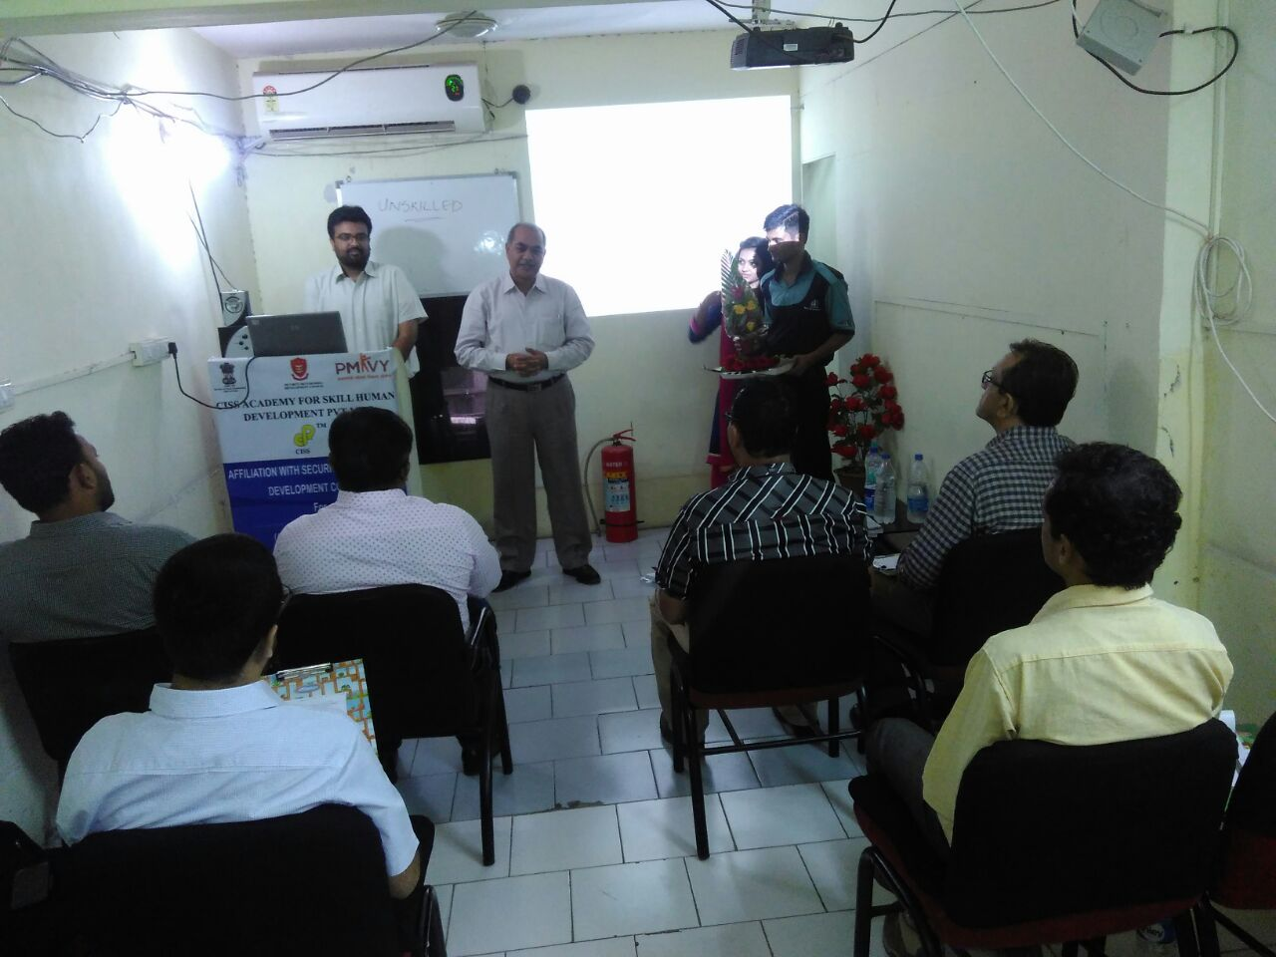  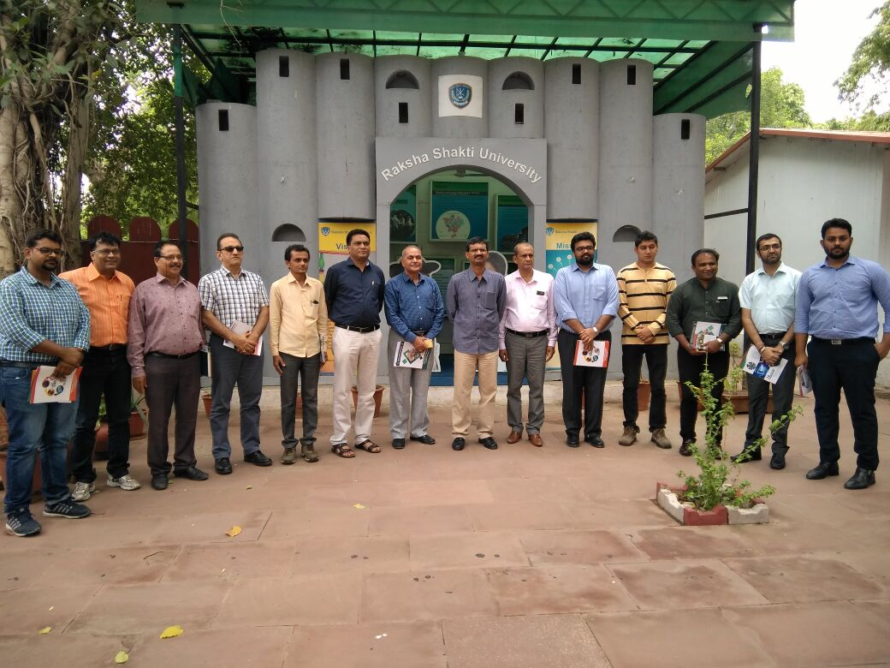
1 | NAME OF THE SSC | Security Sector Skill Development Council
2 | TYPE OF ACTIVITY | International Yoga Day
3 | DATE | 21st June 2017
4 | LOCATION | Various
5 | KEY ACTORS OF THE ACTIVITY | SSSDC Training Partners
6 | ABOUT THE EVENT/ ACTIVITY (in max 200 words) | International Yoga day was celebrated on 21 June 2017. Our TPs actively participated. Pictures of the TPs are attached and was also posted on SSSDC’s twitter handle by Manager Entp.
7 | RELEVANT PICTURES  (ATTACH GOOD QUALITY PICTURES SEPARATELY) | 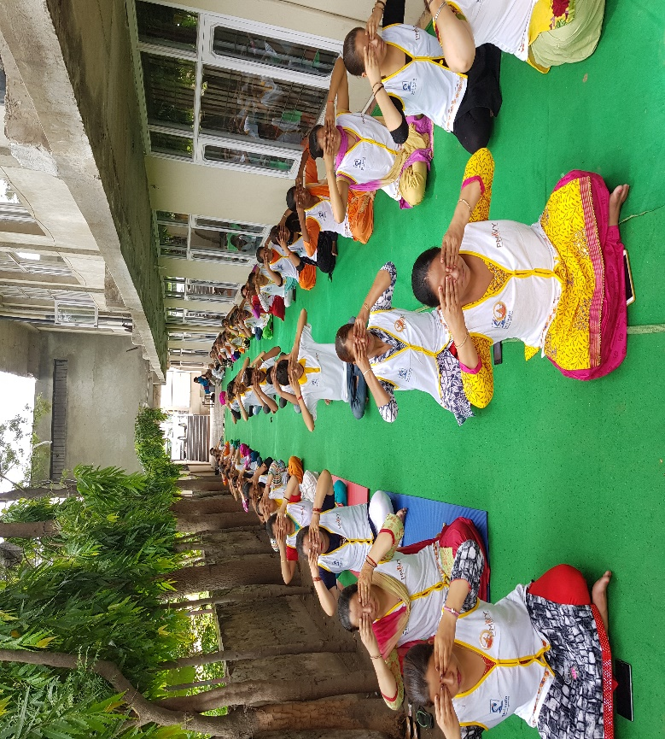  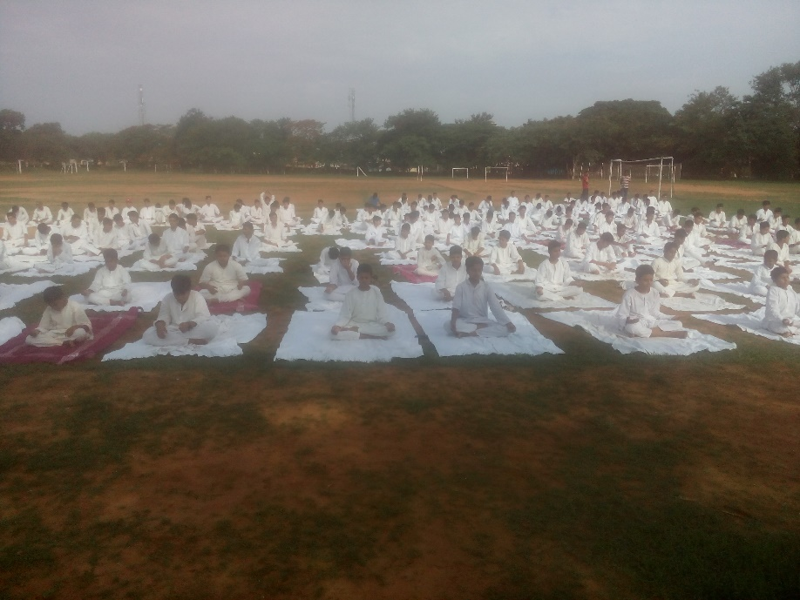
8 | DRAFTED BY | EA to Chairman
9 | VETTED BY | HR & Admin

1 | NAME OF THE SSC | Security Sector Skill Development Council
2 | TYPE OF ACTIVITY | NSFDC Meeting
3 | DATE | 30 June 2017
4 | LOCATION | NSFDC Office
5 | KEY ACTORS OF THE ACTIVITY | Manager Entp
6 | ABOUT THE EVENT/ ACTIVITY (in max 200 words) | Manager Entp visited NSFDC on 30 June 2017 for submitting the proposal for this financial year & following up on payment of the last financial year. Interaction were carried out with the CMD, GM & Deputy GM.
7 | RELEVANT PICTURES  (ATTACH GOOD QUALITY PICTURES SEPARATELY) | NA
8 | DRAFTED BY | EA to Chairman
9 | VETTED BY | HR & Admin

